New Projector link [Here](http://www.infocus.com/projectors/IN1146#accessories) for InFocus IN1146 LED Projector. [Buy Now](http://www.amazon.com/InFocus-IN1146-Projector/dp/B00H9SKMFE) from Amazon

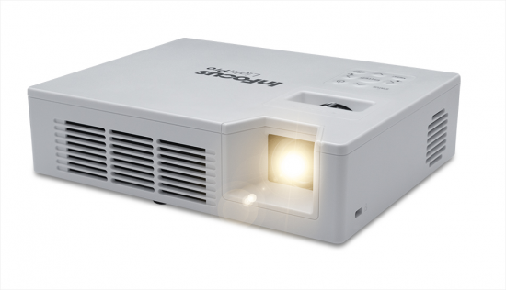

Decision Table

|  |  |  |
| --- | --- | --- |
|  | InFocus IN1146 LED Projector | ASUS P2B |
| Weight | 1.8 pounds | 1.5 pounds |
| Lumens | 1000 lumens | 350 lumens |
| Dimensions | 5.4 x 6.9 x 1.8 | 1⅜ x 5⅜ x 5½ (1.4 x 5.6 x 5.1 web) |
| Resolution | 1280x1080 | 1280x1080 |
| Speaker | 4 W (2x2W) | 1.5 W mono speaker |
| Battery |  | 90 min |
| Keystone | +/- 40ºV (so Yes..?) | Yes |
| Adjustable Leg | No | Yes |
| Lock | No | Yes |

*As with most DLP-based projectors, the IN1146's color brightness is lower than the white brightness, which means that color images won't be as bright as you would expect based on the white brightness. ~via [PCMAG](http://www.pcmag.com/article2/0,2817,2467789,00.asp)

DLP projectors that use a single DLP chip (which I'll refer to simply as DLP projectors). The claim is based on the typical difference in color light output between a 3LCD projector and a DLP projector that both have equal brightness in ANSI lumens, which measures white light output. The problem with the claim is that although it's both true and meaningful, it's also easy to misunderstand.

BAD NEWS :(..

Gregory,

Although it is mobile, this projector still needs to be plugged into a wall outlet. If you need more information, please don't hesitate to reply to this email.

Tony Costa, 2nd Level Support

Can we find a savior? [AAXA M4 Mobile LED Projector](http://aaxatech.com/products/m4_mobile_led_projector.html)

Weight: 2.44 pounds

Lumens: 800 Lumens

Dimensions:

Resolution: max: 1920x1080. WXGA: 1280x800

Speaker:

Battery:

Keystone:

Adjustable Leg:

Lock:

BUT..

More Bad News: 800 Lumens (plugged in). Only 400 lumens battery powered

Other Efforts: [Option 1](http://apollocaster.com/store/index.php?main_page=product_info&products_id=89351&zenid=d8ef60f1f6bfe29dd42c8fe6f1bc76d8)

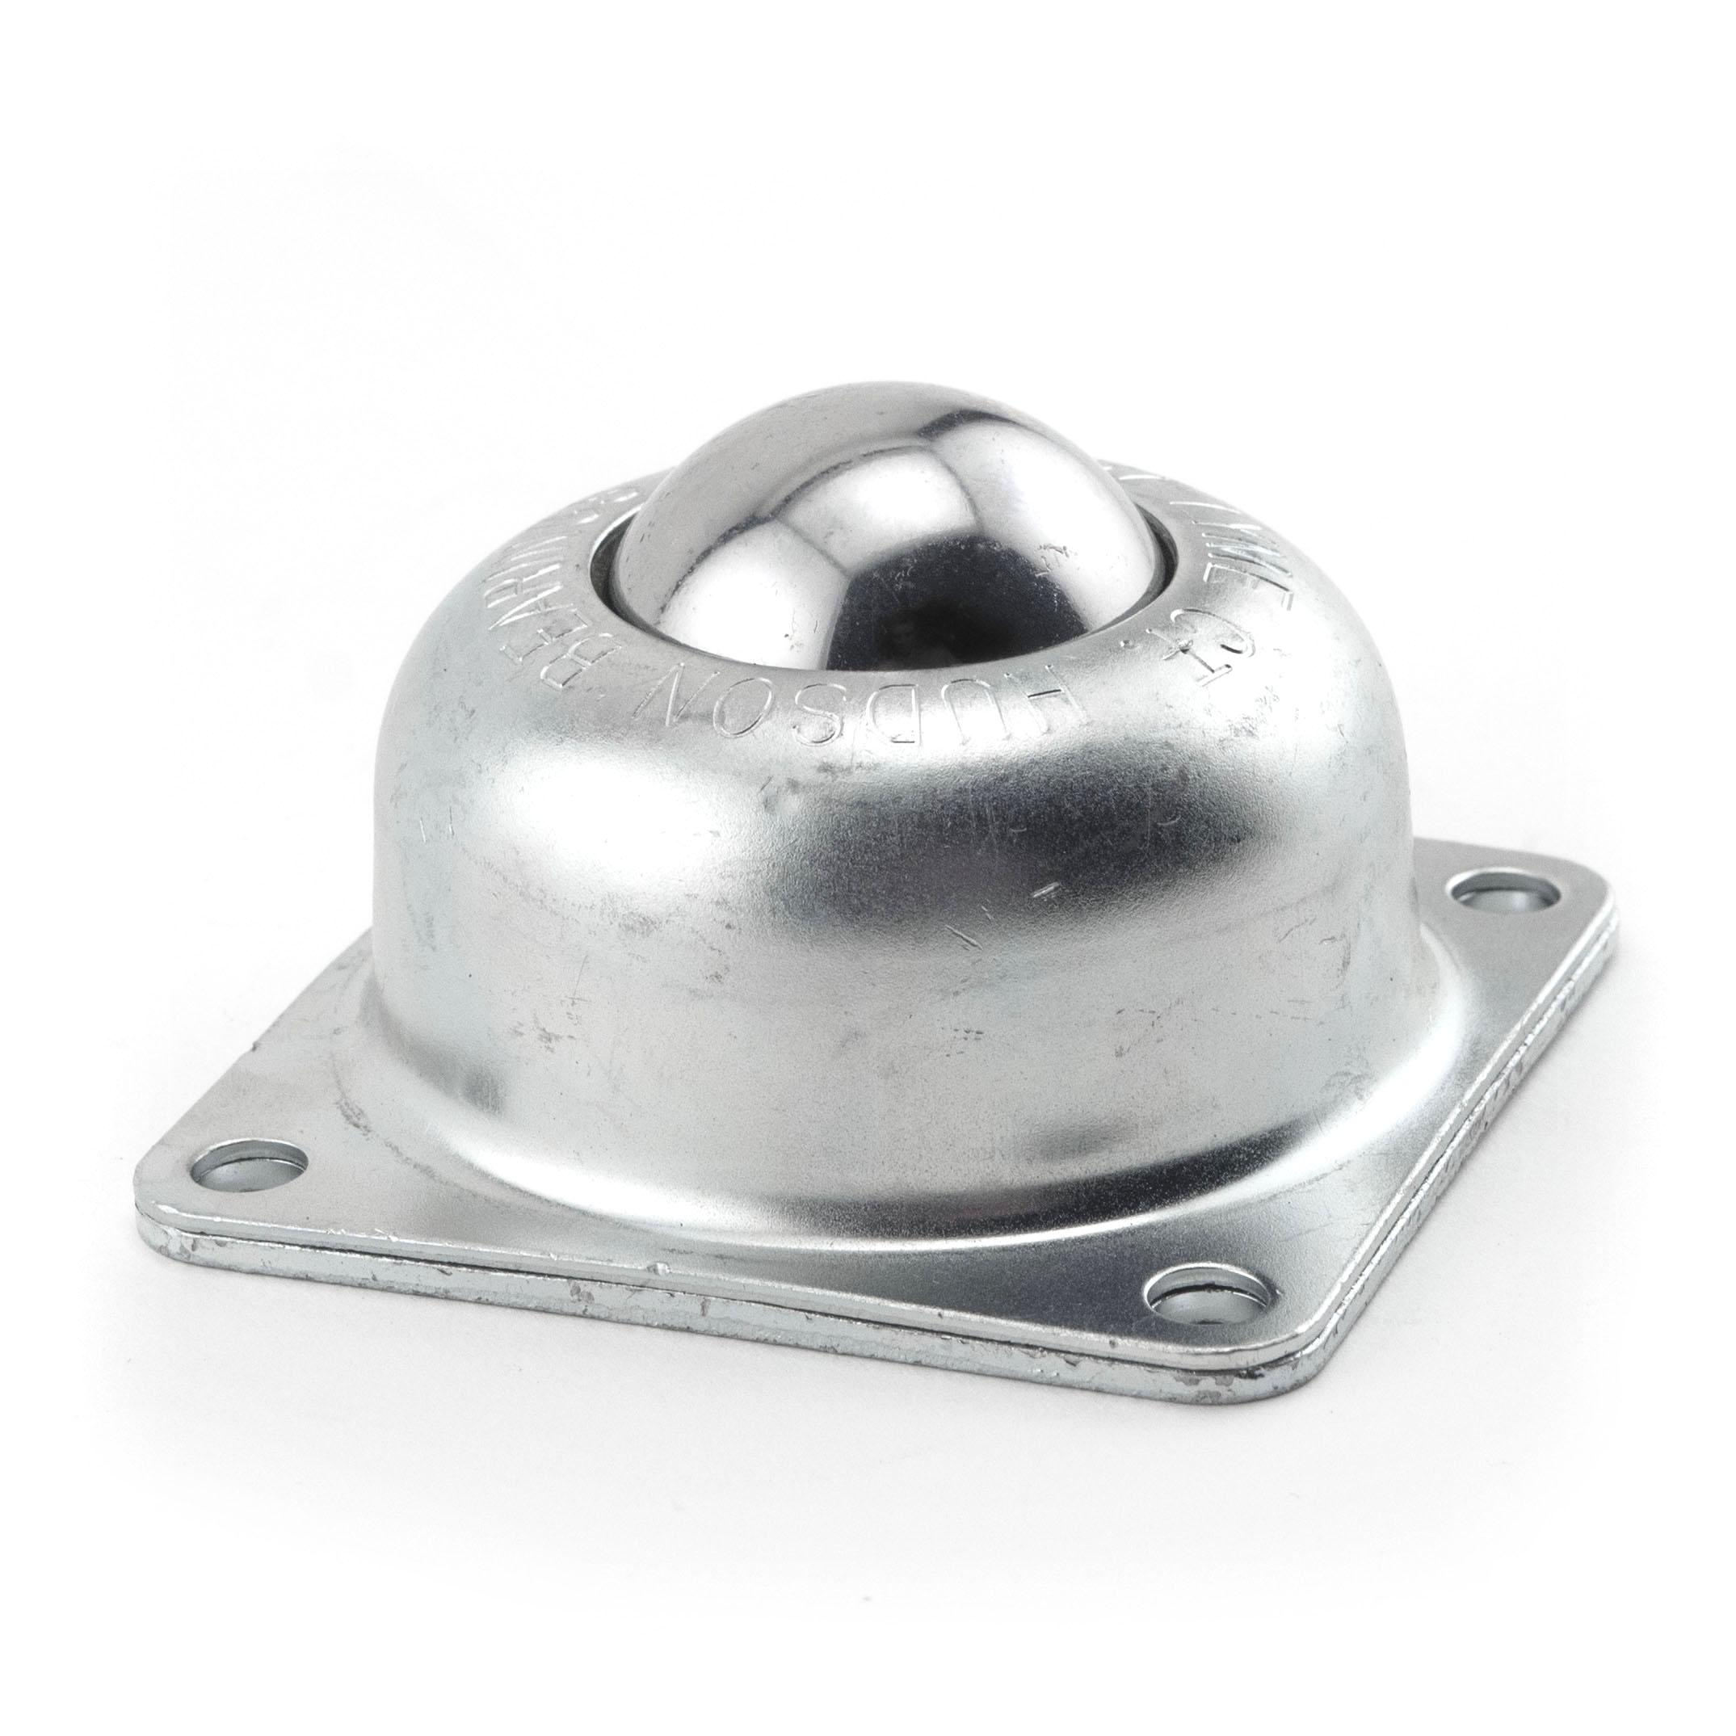 $31.34 . Ball Transfer; 1-1/2" ball

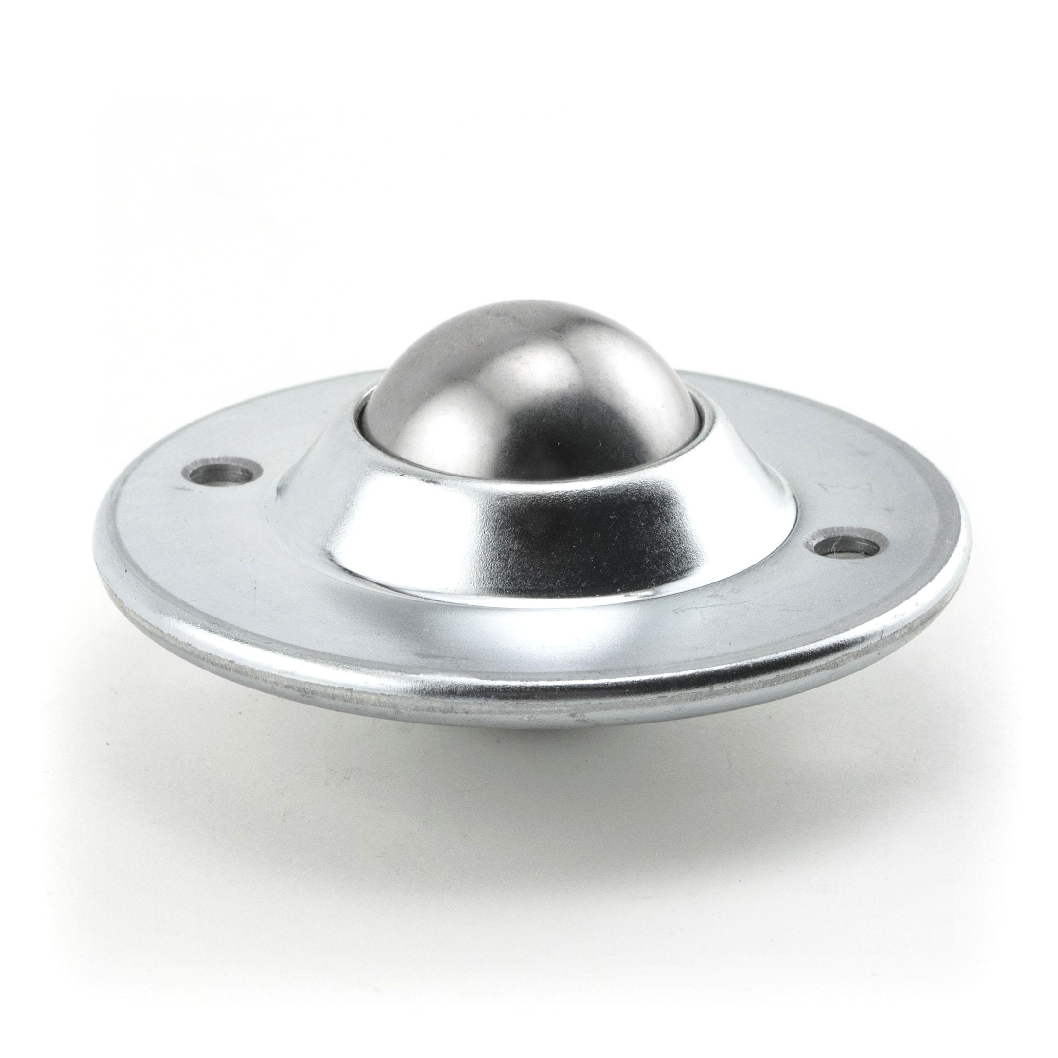 Ball Transfer; Low Profile; 1-1/2" [Option 2](http://apollocaster.com/store/index.php?main_page=product_info&products_id=88817)

* Load Height: 1-1/8"
* Load Rating: 100 lbs.
* $33.95

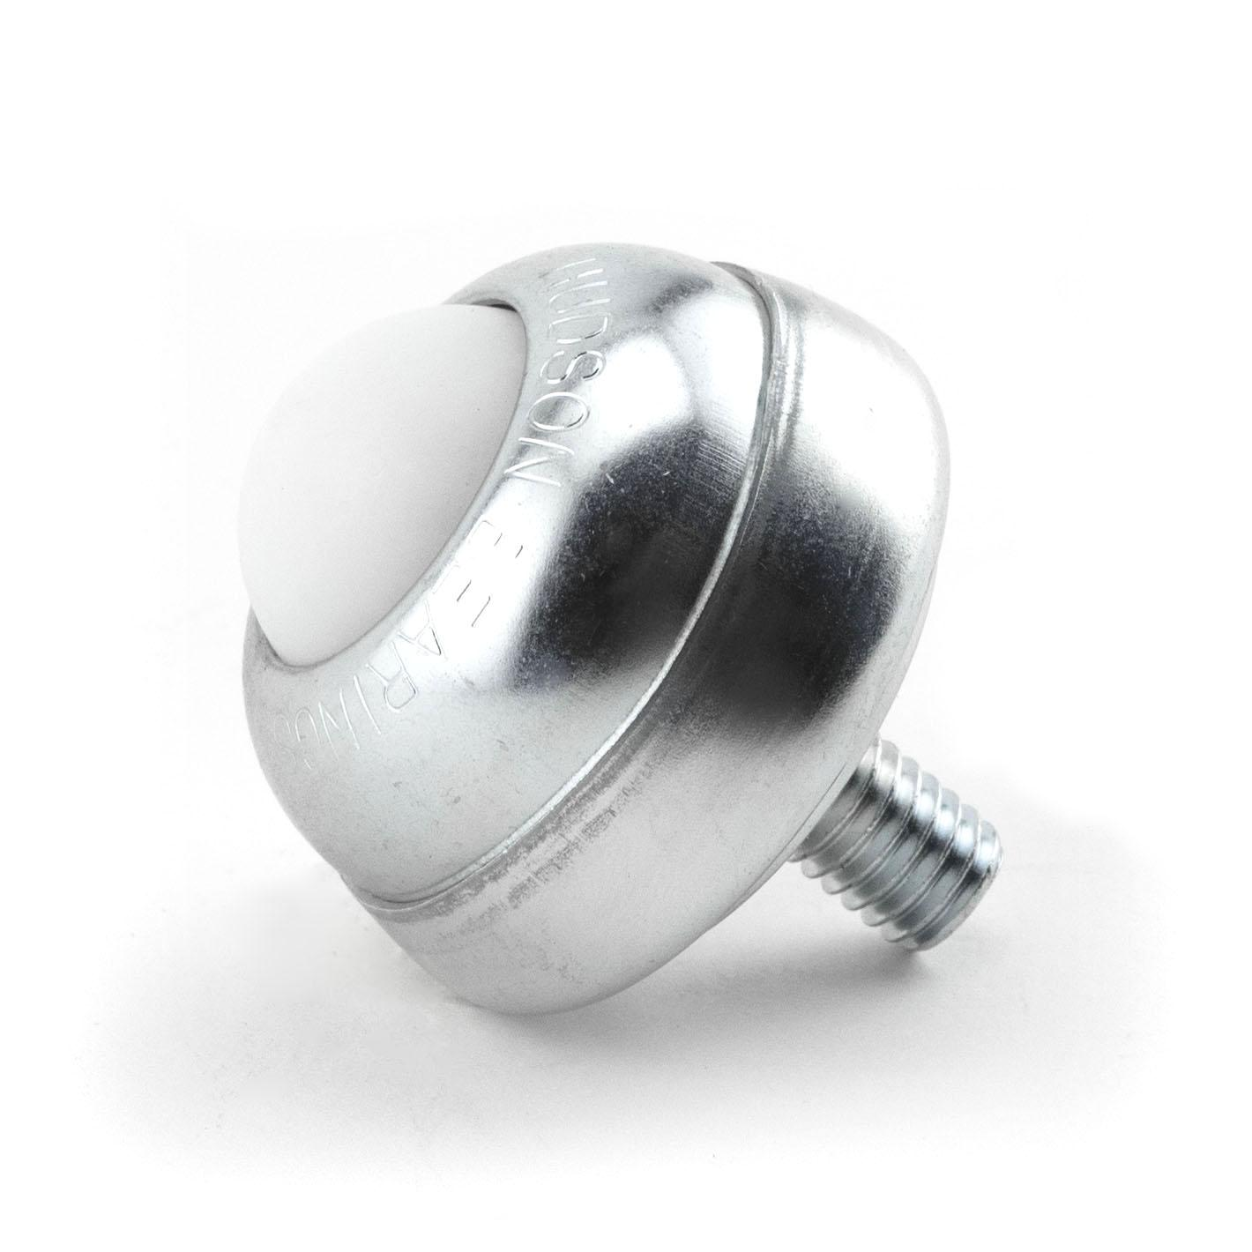Ball Transfer; 1" Nylon ball; Threaded Stud; [Option 3](http://apollocaster.com/store/index.php?main_page=product_info&products_id=89344)

* Load Height: 1-3/8"
* Load Rating: 35 lbs.

## $11.06

# Ball Transfer with a Stainless Steel ball and Threaded Stem connector (#89360)Ball Transfer with a Stainless Steel ball and Threaded Stem connector.

* Load Height: 2-5/16"
* Swivel Radius: N/A
* Load Rating: 250 lbs.

[Option 4](http://apollocaster.com/store/index.php?main_page=product_info&products_id=89360)

<http://www.globalindustrial.com/p/material-handling/conveyors/ball-transfer/1-inch-carbon-steel-main-ball-with-1-4-inch-stud-in-a-carbon-steel-housing>